**TOP 10 BEST REAL ESTATE COMPANIES IN GHANA**

Are you an investor or a family looking to invest or buy a piece of land, a house or an apartment in Ghana from a trusted real estate company? Acquiring a land and building your own house is not easy, as such this article will look at ten of the best real estate companies in Ghana to assist you.

Real estate developers are professionals who are primarily responsible for the acquisition, sale of land, and preparing it for development, manage the construction, and drive the marketing and sale of properties.

It can be residential real estate such as single-family homes, apartments complexes, gated communities or for commercial real estate which is property for business purposes, such as offices, hotels, malls, restaurants etc. or industrial purposes such as for factories and warehouses.

**10.** **GOLDKEY Properties**

Since 1997, which is more than two decades in the Ghanaian real estate market, Goldkey Properties has developed properties for sale or rent in prime locations around Accra, including Airport Residential Area, Cantonments, Ridge, Labone, East Legon and Abelemkpe.

Impeccable design, superior quality, attention to detail, luxury, and security; these are the standards Goldkey demands across all our projects. Customer satisfaction is their driving force, providing their clients with premium quality on residential and commercial developments by making the best use of space and reflecting the modern lifestyle of the Ghanaian.

From the design-driven facades created by leading architects, to the flawless interiors which combine style and practicality, the experience of living in one of our properties is beyond compare

Some of their developments include; Cantonments city apartment at Cantonments, Hammond Court which offers studios, 1- & 2-bedroom apartments and 4-bedroom townhomes at cantoment and Asafu Agyei’s place at Airport Residential.

LOCATION

Goldkey Properties  
5th Floor CH Group Building  
No.1 Rangoon Lane,  
Cantonments City, Cantonments, Accra  
P.O. Box 8743 Accra North, Ghana.  
T: 055 588 7777 | 055 588 7799  
E:[**info@goldkeygh.com**](mailto:info@goldkeygh.com)

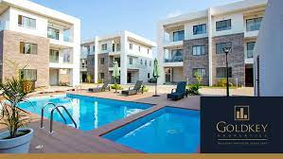

**9. Imperial Homes**

In the past 14 years, Imperial Homes (IHL) have invested heavily in their team of highly experienced, committed and well-resourced professionals and tradesmen to provide our customers with a wide range of flexible solutions from residential, to commercial and retail properties.

Their highly competent team of architects, civil engineers, quantity surveyors, and property managers, specialize in the company’s areas of operation, leverage on their core competencies to provide one-stop construction solutions to our clients.

Some of their development include; Imperial court apartments at Abelemkpe, Imperial Lodge apartments at Dzorwolo, Premier place and the Mankata at airport residential, Imperial Garden at Ridge, Adelaide vista at East Legon, Rangoon residence at Cantonment, Lincoln Court at Cantonment and Danziger apartment at Osu.

LOCATION

Ghana Office

No. 6 Sir Arku Korsah Road, Airport Residential Area, Accra

[**info@imperialhomesghana.com**](mailto:info@imperialhomesghana.com)

[**+233 (0)302 731033**](tel:+233302731033)**/**[**+233 (0)302 731034**](tel:+233302731034)**/**[**+233 (0)573 899899**](tel:+233573899899)**/**[**+233 57 790 6666**](tel:+233577906666)**/**[**+233 (0)277 277010**](tel:+233277277010)

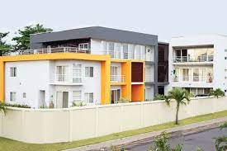

**8.** **REGIMANUEL GRAY LIMITED**

Regimanuel Gray Limited was incorporated in 1991 with the development of housing estates as its core business.The Company’s well-known hallmarks are the timely construction and delivery of high quality, reasonably priced housing units at prime locations which are adequately provided with social amenities and well-developed infrastructure.

To date, it has delivered over 5,000 homes bearing these hallmarks.  Over the years, the company has acquired a great deal of expertise in the execution of turnkey projects, various aspects of site development including road construction, drainage, water and electrical distribution networks installations.

Ever since its inception, the company has had an assemblage of dedicated top calibre local and expatriate personnel managing its affairs and this has resulted in its emergence as the leading private housing estates developer in Ghana.

Their main area of development has been the Greater Accra Region where the majority of their developments in Ghana continue to take place. Their projects can be found at Community 13, Community 14, Community 15, Community 18, Community 19, Community 20, Teshie-Nungua, East Airport, Klagon, Kwabenya and Katamanso all in Accra as well as Essipon, near Secondi in the Western Region.

Driven by our acute concern about the quality of the building materials we use in our projects, Regimanuel Gray Ltd has over the years invested substantially in enterprises engaged in the manufacture of a variety of international standard products for its projects and generally for the housing and construction industry in Ghana and the sub-region.

In 2004, the company expanded internationally into Sierra Leone and continues to explore opportunities in the West African Sub Region to take advantage of the increased demand for planned housing communities in the Sub-Region.

LOCATION

2 La Bypass, La, Accra  
P.O. Box AN 8124, Accra North.  
Tel: +233-302-764682-5, 775727  
Hotline: +233-20 2229916 / 20 2229918  
Fax: +233-302-775730  
Email: info@regimanuelgray.com  
[**sales@regimanuelgray.com**](mailto:sales@regimanuelgray.com)

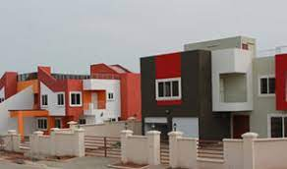

**7. Trasacco Estates Development Company Ltd**

TEDC Ltd is a turnkey developer with strong in-house design teams, construction teams, cost control department, procurement and logistics department. They offer low rise residential properties, high rise residential properties, hospitality and commercial/offices. TEDC projects are always benchmarks for quality and innovation in the industry.

Their service is hinged on creativity, originality and application of strong design principles. Currently engaged in a number of projects across different sectors including master planning, luxury apartments and houses, mixed-use developments, hotels and resorts as well as interior design.  
Their developments Villaggio Vista, Adinkra Heights, and Villaggio Primavera are all in Accra.

Location

TEDC Head Office Building No. 1 Trasacco Valley Accra Ghana

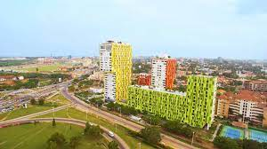

6. **Whitewall Properties**

They are a premium real estate company that prides itself as ambitious and passionate with a team with diverse expertise in their respective fields coming together to create the perfect workforce to discover true comfort in your dream home.

They focus on partnerships, construction, development, sales and management.Their vision is to ultimately be the preferred real estate developer in Ghana. Delivering consistent quality in our products and customer service is the company’s focal mission.

Whitewall Properties is one of Ghana's leading real estate developers with the aim of providing world-class residential homes for the middle and high-end markets. The company builds its reputation on the delivery of quality products and ensuring value, transparency and satisfaction are achieved.

Some of their development include; Brandon Courts at Adjiringanor, Adams Grey townhouses at East Legon Hills and Pine Courts at Cantonments.

Their building come with a gorgeous swimming pool, fitness center, communal garden and more.

LOCATION

Head Office’

18 Osu Badu Street, Dzorwulu,  
Accra, Ghana

Phone

[**050 7010 855**](tel:0507010855)

**WhatsApp**

[**050 7010 855**](http://wa.me/0507010855)

[**Email: sales@whitewallproperties.com**](mailto:Email:%20sales@whitewallproperties.com)

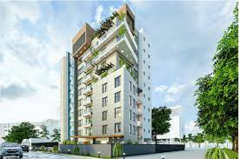

**5. CapeMay Properties**

CAPEMAY properties established in 2008 is a family run business focused on delivering quality buildings at competitive prices, good rental yields for investors and excellent customer service.

With a passion for excellence, they have an ambition to redefine urban living, change the skyline of Accra and thrive to secure CAPEMAY Properties as one of the globally recognized names in the real estate industry. As one of the most trusted real estate developers in Ghana, their pride is in the delivery of elegant and timeless buildings with a keen focus on exceptional customer service. With over a decade of experience in the industry, CapeMay is certainly re-stating the real estate story here in Ghana.

Their flagship development is The Signature apartments in Accra.

CONTACT

80 Spintex Rd, Accra, Ghana;

+233 50 169 0234 / +233 50 169 0235

[**info@capemaypropertiesgh.com**](mailto:info@capemaypropertiesgh.com)

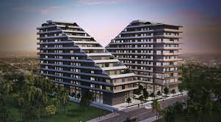

4. **Earlbeam Realty**

Earlbeam Realty is a creative, innovative, and people-oriented organization providing only the highest level of service and standards in the real estate industry. We have major upcoming projects within the prime areas of Accra. This will constitute a lot of residential and commercial units developed between 2019 and 2022.

Our goal is to expand our portfolio by acquiring more lands in strategic and attractive areas in Accra to enable us to develop residential and commercial units to maximize returns and add value to our local setting.

The philosophy of Earlbeam Realty is hinged on the belief that your home is your wealth hence they provide a 2-year warranty on all fixtures and fittings on all their developments. Some of their development include; 23 Odum townhouse at Dzorwulu, Fairfax townhouses at East Legon Hills and Earl Heights apartment at Dzorwulu.

CONTACT

lot, No, 6 George W. Bush Hwy,

Accra – Ghana

[**030 396 6373**](tel:0303966373)[**050 164 6255**](tel:0501646255)

[**sales@earlbeamrealty.com.gh**](mailto:sales@earlbeamrealty.com.gh)

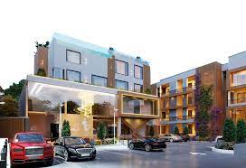

3. **Denya Developers**

Denya Developers has designed and delivered one hundred luxury homes in Ghana, with another one hundred and ten homes currently under construction, and two more developments at the planning stage.

As a member of the Pragnya Group of Companies, we have completed or have under construction 1.6 million square meters of built-up area over thirteen properties and 171 acres in eight different major cities – an area equivalent to 70 Accra Malls.Multi-national developers with over 20 years of experience in the real estate industry, they have built over 5,000 luxury homes

Their brand is well known for the provision of amazing 10years structural warranties and 5years warranties on waterproofing and leakages. Denya Developers has seen significant growth in popularity in recent times and are noted as the real estate developers that create high-end apartments and luxurious homes.

Their experience spans all phases of the development cycle, from land acquisition through to the finishing touch.

In Ghana, our real estate company focuses on Accra's prime locations: Cantonments, Airport Residential, the prime parts of East Legon, Ridge, Ringway Estates and Labone.

Some of their developments include; Tribute House in Airport, The Ivy apartment at East Legon and the The Pavillion in Cantonments made up of 4,3 and 2 executive bedroom apartments.

CONTACT

Denya Developers, Asafoatse Ankaa Road (8th Ringway Rd.), Ringway Estates

+233 (0)268 315 111 (Call) / +233 (0)550 017 909 (WhatsApp) / +233 (0) 50 228 8005

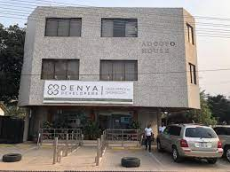

2. **Clifton Homes**

Our developments provide stylish, high specification homes in central locations, at market leading prices. Since 2010 we have built a trusted track record of delivery.

We train our teams to care about the details, whether this is in relation to client communications, managing construction costs, or the meticulous installation of interior fittings. This combination has led to a record of sell-out developments, market leading asset growth and rental yields, and an impressive number of repeat buyers and referrals.

Some of their recent projects include Kai Villas, The Gallery, Embassy Gardens and The Lennox

CONTACT

Clifton Homes Limited  
Head Office, 34 Senchi Street, Airport Residential, Accra, Ghana  
[**+233 (0)20 467 7033**](tel:+2330204677033)**|**[**+233 (0)30 278 6726**](tel:+2330302786726)[**info@cliftonghana.com**](mailto:info@cliftonghana.com)**|**[**www.cliftonghana.com**](https://cliftonghana.com/)

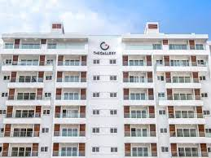

1. **Devtraco Plus**

Devtraco Plus is an industry leading real estate developer that has successfully created a unique niche for its exclusive premium quality housing units in prime areas of Accra, Ghana. Carved out of the well-known echelons of the Devtraco brand, our company promises nothing but excellence in delivery and service. All our developments possess a signature style and character, expertly designed to effectively function with modern finishings, and built with materials that reflect our commitment to quality.

On offer are suites, studios, 1-2-3-bedroom apartments, and 5-bedroom townhouses for sale and rent in Accra, Ghana. They offer bungalows, luxury homes and condominiums.

Birthed from the famous **[Devtraco](https://www.devtraco.com/)** brand, it is a real estate industry leader and trusted real estate developer with three decades of experience in providing professional service to our clients.

Our passion is to satisfy our customers with excellent service delivery. This is our hallmark. Our plush real estate properties possess a signature style and character, expertly designed to effectively function with modern finishing and built with materials that reflect our commitment to quality and luxury. We stand out with our competitive price and flexible payment plan options structured with our customers in mind.

As a testament to our commitment to quality, we have won many awards over the years. We consistently picked up several category awards in best apartments, best development marketing, best mixed-use development, and best architecture during the International Property Awards over the period 2015-2019.

 Devtraco Plus developments by location here:

Cantonments:[**The Pelican Hotel Apartments**](https://pelican.devtracoplus.com/)**,** [**Acasia apartments**](https://devtracoplus.com/projects/acasia-apartments/)**, Acasia townhomes,** [**Henrietta’s Residence**](https://devtracoplus.com/projects/henriettas-residences/)

**Labone:** [**Avant Garde**](https://devtracoplus.com/projects/the-avantgarde/)**,** [**The Edge**](https://devtracoplus.com/projects/the-edge/)

**Dzorwulu:** [**The Niiyo**](https://devtracoplus.com/projects/the-niiyo/)

**Roman Ridge:** [**The Nova**](https://nova.devtracoplus.com/)

**Airport Residential Area:** [**Palmer’s Place**](https://devtracoplus.com/projects/palmers-place/)

CONTACT

+233 (0) 302 798 692

+233 (0) 270 000 004

[**INFO@DEVTRACOPLUS.COM**](mailto:INFO@DEVTRACOPLUS.COM)

DEVTRACO PLUS OFFICES  
NO. 8B, SIR ARKU KORSAH ROAD  
AIRPORT RESIDENTIAL AREA  
ACCRA-GHANA

